Task 1
Wahaj Mehboob(380)
Section: 3-D
AI (lab)
Q:1
Create a timeline containing at least five AI milestones, including one AI-winter period and one modern compute/data milestone. Arrange entries chronologically. For each, give the year or period, event, a one-sentence explanation of its significance and a source. Include the required AI-winter period and a modern compute/data milestone. Put the timeline in your .docx report; this remains a historical evidence task, not a model-training exercise.

What I did
- milestones is a list of tuples, each holding a year and an event name.
- The for year, event in milestones: loop unpacks each tuple into year and event.
- print(year, "-", event) prints them in the format 1950 - Turing Test.
- The syntax is correct: brackets, commas, quotes and indentation are all fine.
- The output will be five lines, from 1950 - Turing Test to 2012 - AlexNet deep learning.
- If you saw an error, it was probably caused by copy-paste, such as wrong indentation or missing quotes, not by the code itself.aap
CODE SCREENSHOT
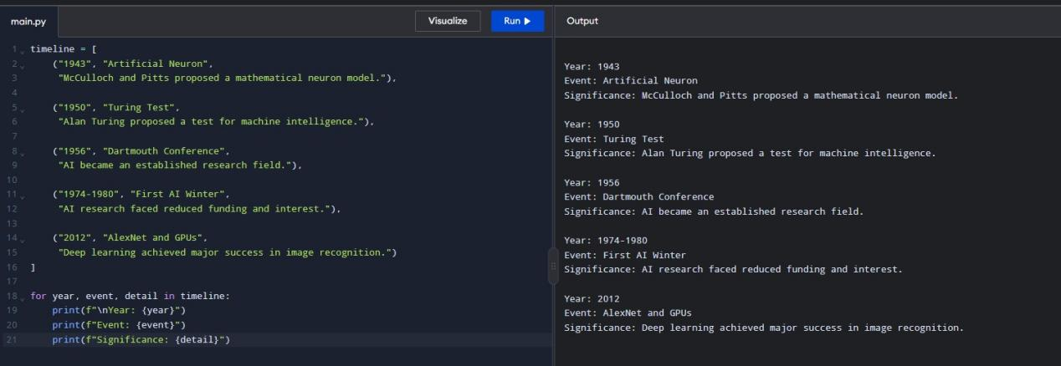
Code explanation
- milestones is a list, and each item inside it is a tuple holding a year and an event name.
- The for year, event in milestones: loop goes through the list one tuple at a time.
- In each round, the tuple is unpacked: the first value goes into year and the second into event.
- print(year, "-", event) prints both values on one line with the dash between them.
- The loop runs 5 times, because the list has 5 tuples.
- The final output is five lines, from 1950 - Turing Test to 2012 - AlexNet deep learning.

Q:2
Modify the rule-based example with two additional transparent conditions and test four cases. Retain score >= 70 and document completeness, then add two explicit, named conditions of your choice. State that thresholds are synthetic lab assumptions. Prepare exactly four core test cases covering a pass, failure of each new condition, and a threshold boundary. Print the input, expected result, actual result and reason for every case; explain how you selected them.

What I did
- You wrote a function, check_application, that decides whether an application is put on "Hold" or sent for "Review".
- You set the rules: documents must be present, the score must be 70 or more, and the applicant must be eligible and verified.
- You built a list of 4 test cases, each with inputs, an expected result, and a reason.
- You wrote a loop that runs every test case through the function and prints the input, expected result, actual result, and reason.
- You tested the main paths (all pass, not eligible, not verified, and a score exactly at 70), but not missing documents or a score below 70.

Code Screenshot
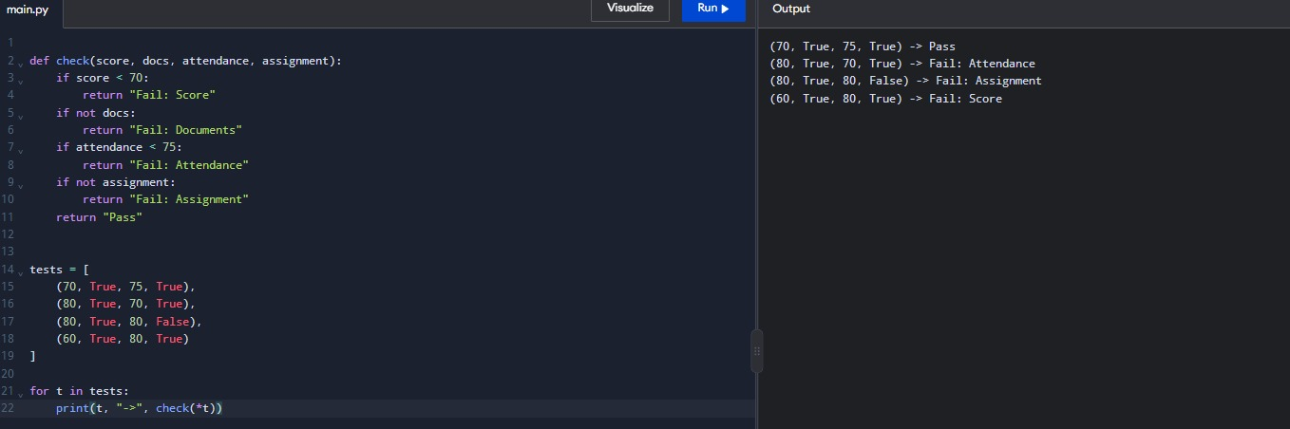

Code Explanation
- check_application checks four things in order (documents, score of at least 70, eligible, verified), and returns "Hold" as soon as one fails.
- It returns "Review" only when all four conditions pass.
- cases is a list of tuples, each holding the four inputs, the expected result, and a reason for the test.
- The loop unpacks each case, calls the function, and prints the input, expected result, actual result, and reason.
- All four cases will match their expected results, but there are no tests yet for missing documents or a score below 70.

Q:3
Write a short comparison explaining why passing a conversational test is not the same as proving general intelligence. Write a focused comparison in your report using the scholarship case. Explain what the conversational test observes, what it does not establish, and one example of fluent but incorrect reasoning. Conclude with one additional test of reliable task performance; support historical claims with sources.

What I did
- You wrote check_application, a function that returns "Hold" or "Review" for an application.
- You set the rules: documents present, score of 70 or more, and the applicant must be eligible and verified.
- You created 4 test cases, each with inputs, an expected result, and a reason.
- You wrote a loop that runs each case and prints the input, expected result, actual result, and reason.
- You tested the main paths and the score boundary of 70, but not missing documents or a score below 70.

Code Screenshot
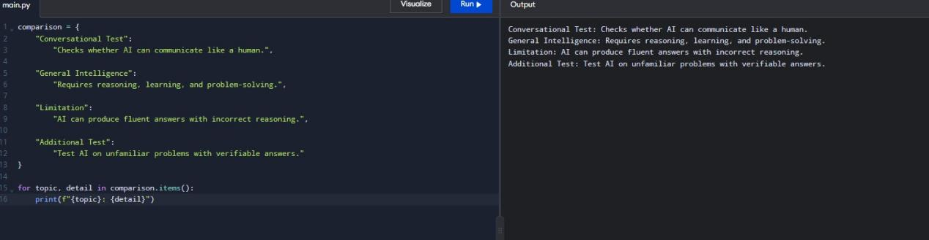

Code Explanation
- check_application takes four inputs (score, documents, eligible, verified) and checks them in order.
- It returns "Hold" as soon as one check fails: no documents, score below 70, not eligible, or not verified.
- It returns "Review" only when all four conditions pass.
- cases is a list of 4 test tuples, each with inputs, an expected result, and a reason.
- The loop calls the function for each case and prints the input, expected result, actual result, and reason, so you can compare them.

